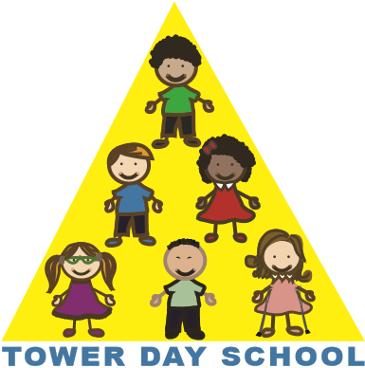
Tower Day School

Early Drop-Off Program

Application Form

The Early Drop-Off Program operates 7:45 am - 8:30 am. Space permitting, children may be enrolled permanently from one to five days per week. Space is limited to 10 children per day. The program is staffed by 2 current Tower Day School teachers.

Application Information

- Tuition for the Early Drop-Off Program is on a yearly tuition basis.
- Tuition is payable in full with this application and is non-refundable. Should the program be canceled, your payment will be applied to your child’s classroom tuition.
- There is no sibling discount offered for this program.
- Enrollment in a class at Tower Day School does not guarantee enrollment in the
Early Drop-Off Program.
- Tower Day School reserves the right to cancel this program due to insufficient enrollment.

Early Drop-Off Program Tuition

One Day $370.00
Two Days $740.00
Three Days $1,110.00
Four Days $1,480.00
Five Days $1,850.00

Please make checks payable to: Tower Day School

Child’s Name: ____________________________________________________

Parent’s Name: ___________________________________________________

Please select the day(s) requested for the Early Drop-Off Program:

Monday _____Tuesday _____Wednesday _____Thursday _____ Friday _____

I have read the above application information.

Signature_______________________________________Date______________

5 Summer Street, Lynnfield, MA 01940 towerdayschool@gmail.com 781.334.5576 www.towerdayschool.org

